LBG - Modern Engineering Bootcamp

Date: 15th October 2021

Project review / submission

Before you log off today, we will ask you to provide us with the following screenshots:

* Take a screenshot of Jenkins you installed into VM (accessed via external IP address).
* Take a screenshot of your Jenkins job running.
* Take a screenshot of your Jenkins job completed.
* Take a screenshot of a list of Docker images you pushed into your GCR (GCP Container Registry) console.
* Take a screenshot of list of applications deployed into your GCP GKE cluster (in GCP Console).

This is something for you to show off / demonstrate / review and reflect on what you have learnt and practiced during the last three weeks of this bootcamp.

It will also help you to assess your understanding and it will be an opportunity, if you want to share this with us, for us to provide you with a feedback about what you completed and opportunities for improvement. This is not with the purpose of marking pass/failure, but more for you to take this away with you and review in your own time and for future training that you may want to continue.

Also, we will guide you to save all the work that you have produced on GitHub, step by step so you don’t lose anything.

Please let me know if you have any questions and we will be happy to assist you

* Jenkins Job that has completed

Script: for building and pushing image to GCR:

#!/bin/bash

npm install

npm test

docker rmi $(docker images --filter=reference="gcr.io/lbg-training/node-app:*" -q)

docker build -t gcr.io/lbg-training/node-app:${BUILD_NUMBER} .

docker push gcr.io/lbg-training/node-app:${BUILD_NUMBER}

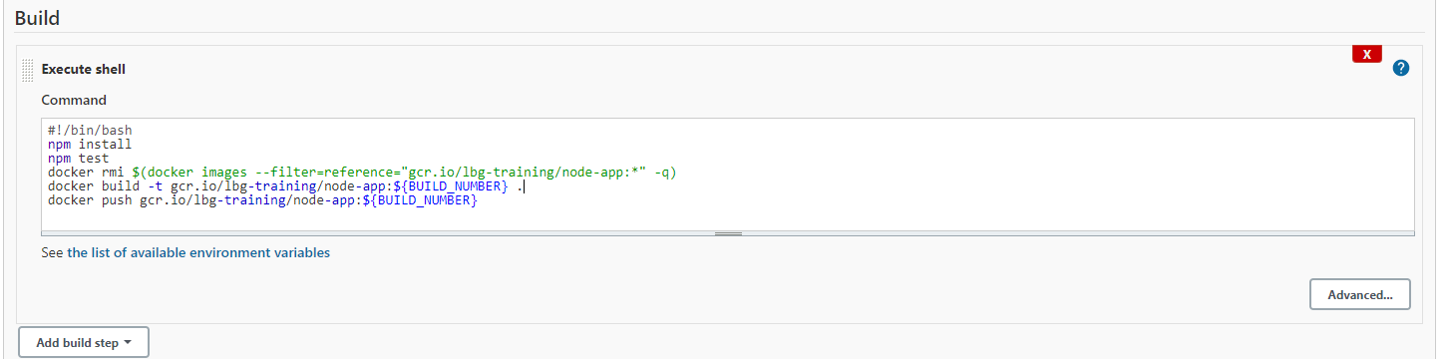Build under Jenkins:

Completed Build:

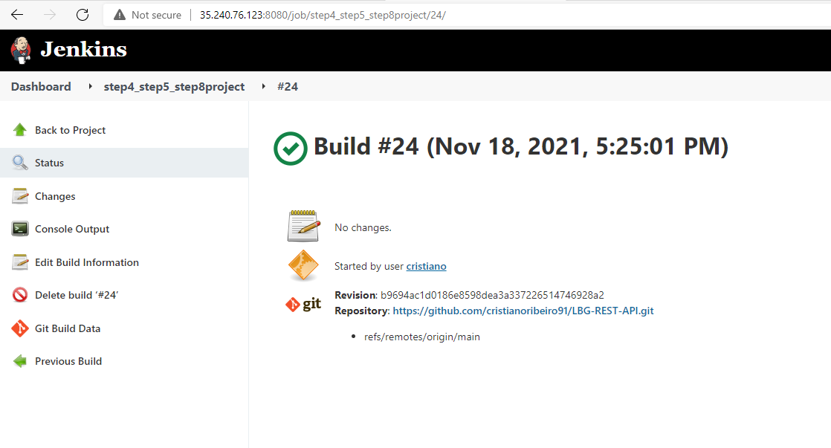

Ensure that the project from github is configured under Source Code Management on Jenkins

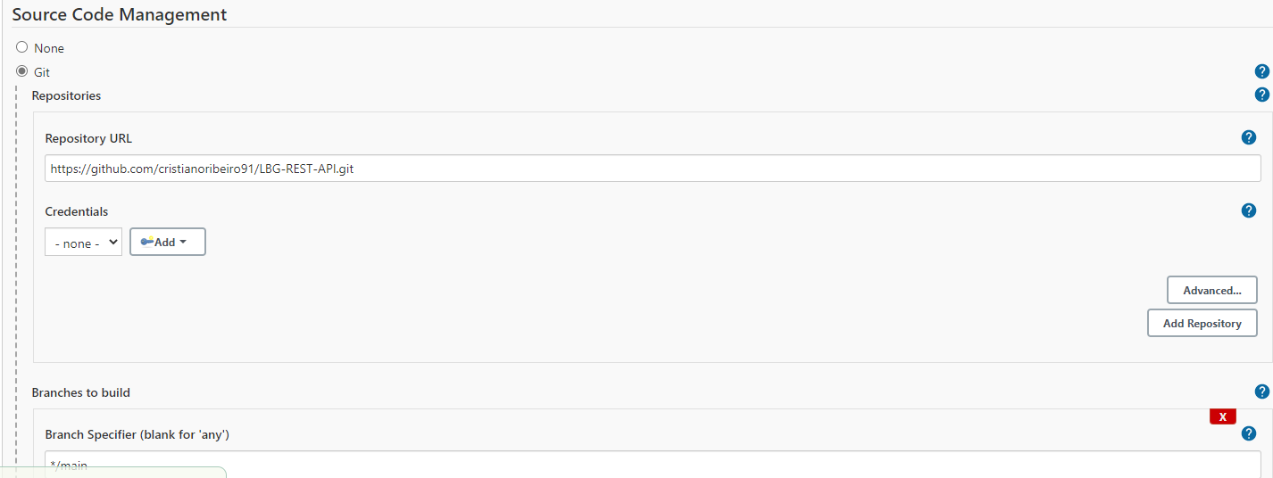

Example of completed output:

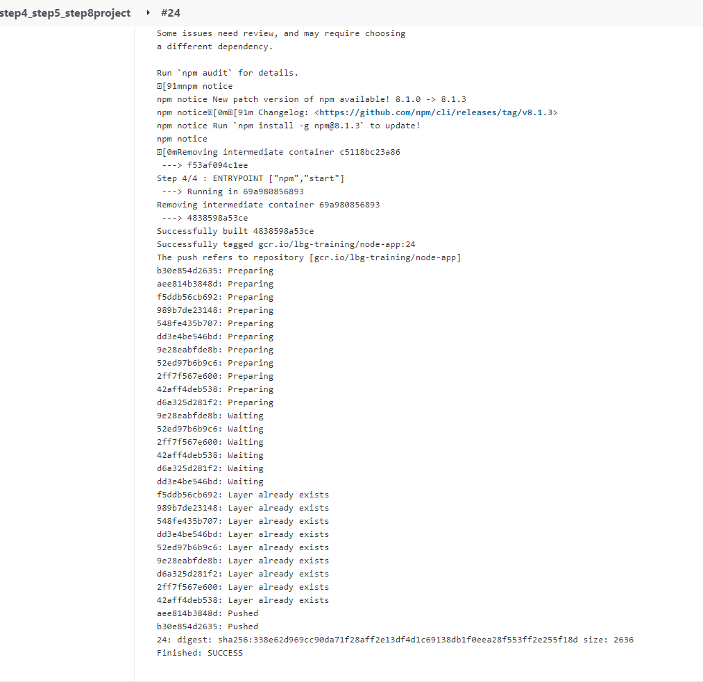

* Docker image pushed into your GCR (GCP Container Registry) console.
* Applications deployed into your GCP GKE cluster (in GCP Console). Useful commands to list GKE:

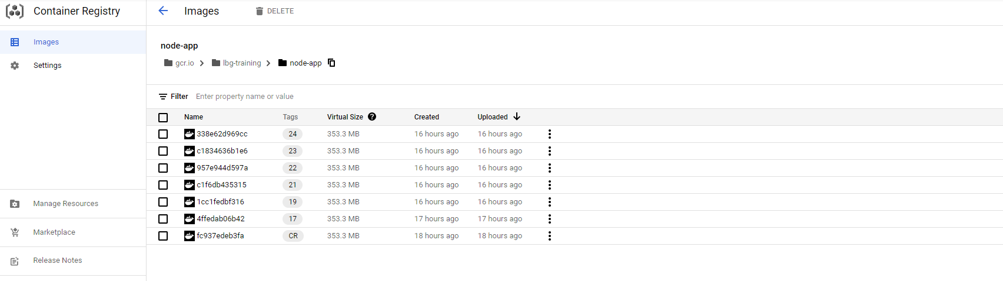

Kubectl get pods,rs,services – will return all pods, replicasets and services running

Kubectl apply –f deploy.ymal – apply the deployment manifest

Kubectl delete –f deploy.yaml – deletes everything created as part of deployment manifest.